
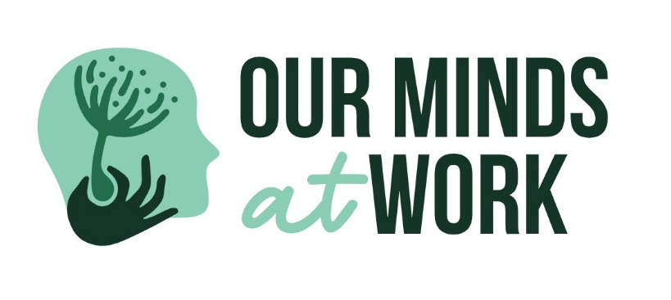

🧠 Resilience First Aid (RFA)
Role: Prevention & capability building
Contribution: - Stress regulation and resilience skills - Burnout and overload prevention - Shared wellbeing language
Framework Placement: STRENGTHEN
Resilience Skills for the Workplace
RSA & RFAST Training
RSA (Resilience Skills & Awareness) and RFAST (Resilience First Aid – Short Training) are practical, preventative training programs designed to reduce psychosocial risk and strengthen everyday resilience in the workplace.
These programs support early awareness, healthy coping strategies, and safe conversations — helping teams address challenges before they escalate into crisis.
Why this training matters
SafeWork NSW requires organisations to actively manage psychosocial hazards as part of their WHS obligations. RSA and RFAST help demonstrate proactive, reasonable controls by building capability and supporting safer work practices.
RFAST – Resilience First Aid (Short Training)
A short, accessible session suitable for all staff.
• Recognise early signs of stress and psychosocial risk
• Learn simple tools to manage pressure and maintain boundaries
• Build confidence to have safe, supportive conversations
• Understand when and how to escalate concerns
Best suited for: all staff, frontline teams, induction or refresher training.

RSA – Resilience Skills & Awareness
A deeper capability-building program for roles exposed to ongoing pressure or emotional demands.
• Understanding psychosocial hazards and their impacts
• Building sustainable resilience (not ‘push through’ culture)
• Emotional regulation, recovery, and boundary-setting skills
• Supporting others without absorbing risk
Best suited for: peer support champions, team leaders, supervisors, and high-demand roles.
Outcomes for organisations
• Early identification and prevention of psychosocial risk
• Reduced burnout and escalation to crisis
• Stronger, healthier workplace culture
• Alignment with SafeWork NSW psychosocial hazard expectations
RSA and RFAST work best when layered with Mental Health First Aid and clear escalation pathways as part of a people-first wellbeing approach.

