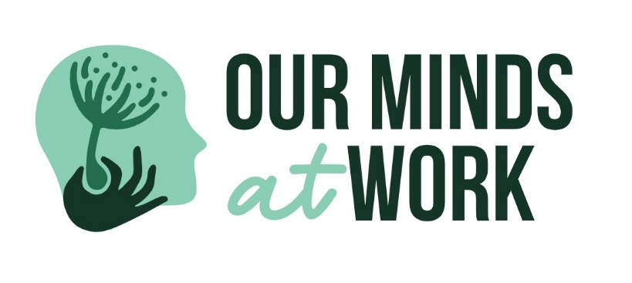

🤝 Mental Health First Aid (MHFA)
Role: Crisis support & escalation capability
Contribution: - Recognise mental health distress and crisis - Provide initial support - Guide safe escalation and referral
Framework Placement: CONNECT
Mental Health First Aid (MHFA) is an evidence-based training program that equips people with the skills, confidence, and language to recognise and respond to mental health challenges in the workplace and community.
Delivered in line with Mental Health First Aid Australia guidelines, this course supports early intervention, reduces stigma, and helps prevent issues from escalating into crisis.
MHFA is not about becoming a therapist. It is about knowing how to notice, how to respond, and how to connect people to the right support safely and appropriately.
WHAT THE COURSE COVERS
Participants learn how to:
• Recognise early signs and symptoms of common mental health problems, including anxiety, depression, substance use and trauma-related conditions
• Respond effectively to mental health crises such as suicidal thoughts, panic attacks, self-harm or severe distress
• Use the ALGEE Action Plan to provide structured, calm and non-judgemental support
• Start safe, supportive conversations that encourage help-seeking
• Guide people towards professional help and workplace or community supports
• Understand boundaries, role clarity and self-care when supporting others
OUTCOMES FOR INDIVIDUALS AND ORGANISATIONS
After completing MHFA, participants are able to:
• Feel confident and prepared to support someone experiencing mental ill-health
• Act early to reduce risk and prevent escalation
• Strengthen a culture of psychological safety and care
• Support organisational obligations around psychosocial hazard awareness
• Know when and how to escalate concerns appropriately
CERTIFICATION
Participants who successfully complete the course and assessment receive:
• Accredited Mental Health First Aider certification
• Certification valid for 3 years, with refresher training available
WHO THIS COURSE IS FOR
MHFA is suitable for:
• Workplace peer supporters and wellbeing champions
• Managers, supervisors and team leaders
• HR, WHS and People & Culture professionals
• Community workers, volunteers and frontline staff
• Any organisation wanting to strengthen mental health capability
MHFA AS PART OF A LAYERED APPROACH
Mental Health First Aid is most effective when it sits within a broader wellbeing and safety framework. While MHFA provides crisis response and early support, ongoing systems, prevention strategies and organisational oversight are essential for sustainable impact.
MHFA forms the foundation layer of a mentally healthy workplace, supporting people to connect, care and act early.

